Title: TBD

Subtitle: TBD

Swing states sometimes elect the president by mere thousands of votes out of millions. Does that tend to happen at the county level frequently?

**Main questions I’m asking and answering:**

1. What’s the scope of what I’m studying?
   1. i.e. How many votes? How many states? What level? i.e. counties? – get a more granular view
2. Swing states sometimes elect the president by mere thousands of votes out of millions. Does that tend to happen at the county level?
   1. Which party tends to win races?
   2. Which party tends to get more votes?
   3. How common are close elections, at the county level?
3. Do counties with cities in them tend to vote overwhelming for Democrats? How does having a city in the county affect the vote?
   1. Are counties with cities significantly more likely to vote for Democrats?
   2. Are counties with cities significantly more likely to have close elections than non-cities? – as a way of answering: Do cities tend to vote overwhelming for Democrats?

**Introduction**

Swing states – states where the two major political parties enjoy roughly equal levels of support among voters -- are crucial in determining the ultimate winner of American presidential races. Since most states give all of their electoral votes to a single party, sometimes only a few thousand votes in a swing state can determine the winner of the entire national presidential election.

While overall, both Democrats and Republicans have equal support among voters in swing states, I wanted to understand if that dynamic extends to the local level. In other words, I want to understand: **do swing state voters support Democrats and Republicans at fairly equal rates at the county level, or do they only support them roughly equally when you tally up all of the votes from all over the state**?

While the winner of the state’s delegates to the electoral college are generally determined by the overall popular vote, I wanted to understand whether similar dynamics are at play at the county level within swing states. In other words, **do voters in swing states generally vote for both Democrats and Republicans at fairly equal rates, or do we only see close elections when voting for the president?**

**Methodology**

I looked at 11 swing states – Colorado, Florida, Iowa, Michigan, Minnesota, New Hampshire, North Carolina, Ohio, Pennsylvania, Virginia, and Wisconsin. I spend a lot of my analysis looking at the county level because it can give us a better idea of the local politics.

Voters cast **___ million total votes** combined in all of the swing states I analyzed. On average, voters cast **__ million** votes in each state. However, the votes cast in each state varied from **___ million** votes in New Hampshire (3,566,633) to **___ million** in Florida.

Because the number of votes cast in each state varies so much, I focus my analysis on the margin.

**Margin**

The margin is the percentage of votes cast that a party won by. For example, the margin for all elections in Alamosa County, Colorado was 5%. That means that one party got 5% more votes than the other.

We can think of a close margin as 10% or less, and a very close margin of 2% or less.

**Swing states sometimes elect the president by mere thousands of votes out of millions. Are races close at the county level?**

*First of all, which party tended to win races?*

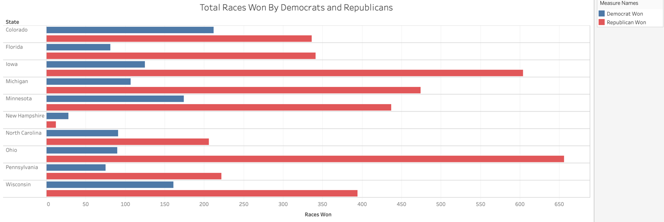

In all states except New Hampshire, Republicans overwhelmingly won elections held in the 2018 midterms. This means that Republicans likely hold most of the power within counties.

Note: this looked at the winner for all races. However, in most cases, the counties were voting for state-wide offices, so this will not map to the offices that were actually elected. This gives us an idea of what would happen if those elections happened at the county-level.

*Okay, but which party got more votes?*

This table shows the difference in total votes for Democrats and Republicans. If the difference was negative, Republicans got more votes, and if it was positive, Democrats received more votes.

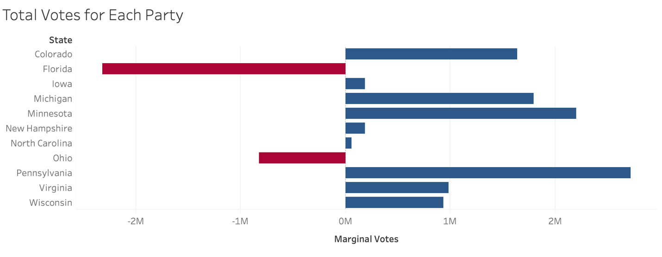

Interesting. In each state, Democrats received more total votes than Republicans, generally by at least 1 million. In a few states, Republicans and Democrats were fairly evenly matched – in Iowa and New Hampshire, the difference was only 185,000, and in North Carolina it was only 60,000. This stands in contrast to the fact that Democrats lost most of the races within counties, suggesting that certain counties hold most of the Democrats.

**How does having a city in the county affect the vote?**

There’s a common narrative in American political discourse that cities vote for Democrats, and everywhere else votes Republican. Is that true?

In order to answer this question, I set up a chi-square test of independence to see if whether a county had a big city in it was related to whether the majority of a county’s votes went to Democrats. I also ran Fisher’s R, because the total number of counties I analyzed was fairly small and chi-square tests are less accuracy on small sample sizes. I defined a big city as a city with that had a population of over 100,000 in the 2010 census.

I calculated values for the following table:

|  |  |  |
| --- | --- | --- |
|  | County contained a big city | County DID NOT contain a big city |
| Majority of votes went to Democrats | 54 | 220 |
| Majority of votes went to Republicans | 13 | 644 |

The tests tell us whether not the two variables of whether a county contained a big city and which party the majority of the county’s votes went to are related.

The p-value for both the chi-square test and Fisher’s R was < 2.2e-16, or just about 0, which means that whether a county contains a city and whether the votes went to Democrats or Republicans are definitely related. However, it does not tell us whether cities voted for Democrats or Republicans in general.

How can we find that out? It’s actually a fairly simple thing to eyeball. I plotted the margin between votes for Democrats and Republicans in each county on a graph, with a negative margin for Republicans and a positive margin for Democrats.

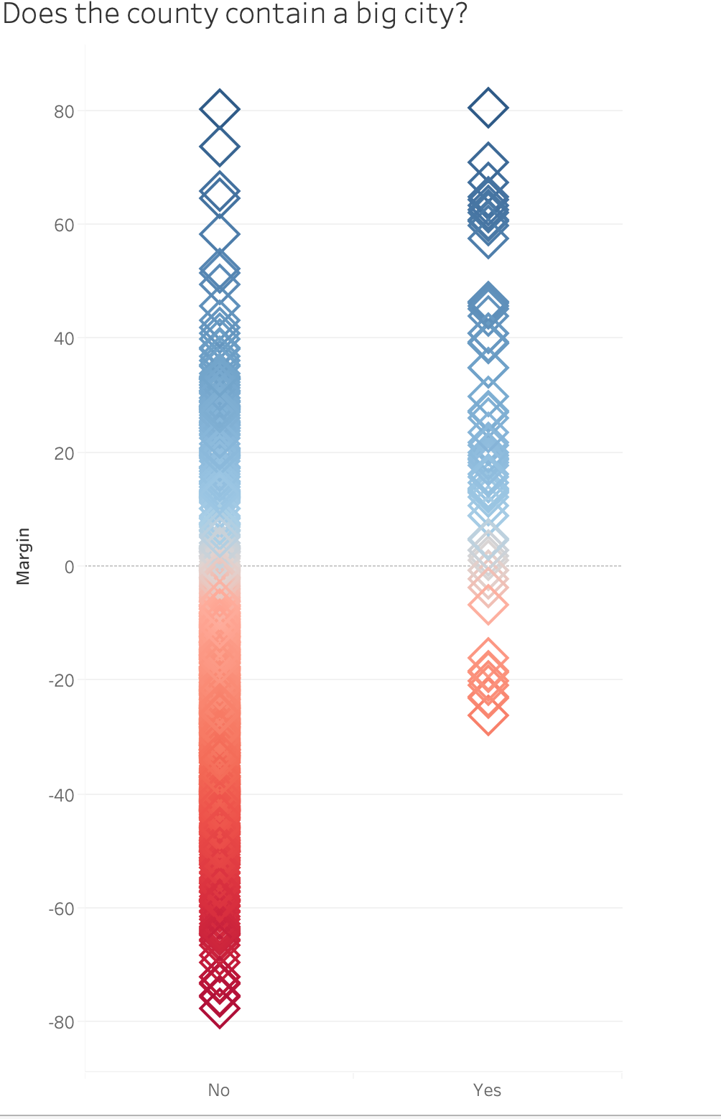

Looking at this graph, it’s pretty clear that Democrats got the most votes within counties that contained cities.

Though Democrats generally won in cities, did they win overwhelmingly? *In other words, were small margins less likely to happen in counties with big cities than in counties without them?*

I ran a chi-square and Fisher’s R tests on the following tables:

|  |  |  |  |  |  |  |
| --- | --- | --- | --- | --- | --- | --- |
|  | County contained a big city | County DID NOT contain a big city |  |  | County contained a big city | County DID NOT contain a big city |
| Margin was greater than 10% | 54 | 721 |  | Margin was greater than 2% | 63 | 834 |
| Margin was less than or equal to 10% | 13 | 143 |  | Margin was less than or equal to 2% | 4 | 30 |

The p-values were well over 0.10 in all cases, ranging from 0.3 to 0.67. This tells us that counties with cities were no more likely to have big (or small) margins than counties that didn’t contain cities.

So far, we’ve answered:

* Who wins the most races? Republicans.
* Who gets the most votes? Democrats.
* Do cities affect which party gets the most votes? Yes, and Democrats get the most votes within cities.

But we still haven’t completely answered: **Do Democrats and Republicans generally receive similar percentages of the vote at the county level?** We partially answered that with the question about cities, but we can do better.

We can think of a close margin as 10% or less, and a very close margin of 2% or less. Anything above 10% is not a close margin.

What was the average margin in each state? *In other words, what was the average amount that a party won the votes in the county by?*

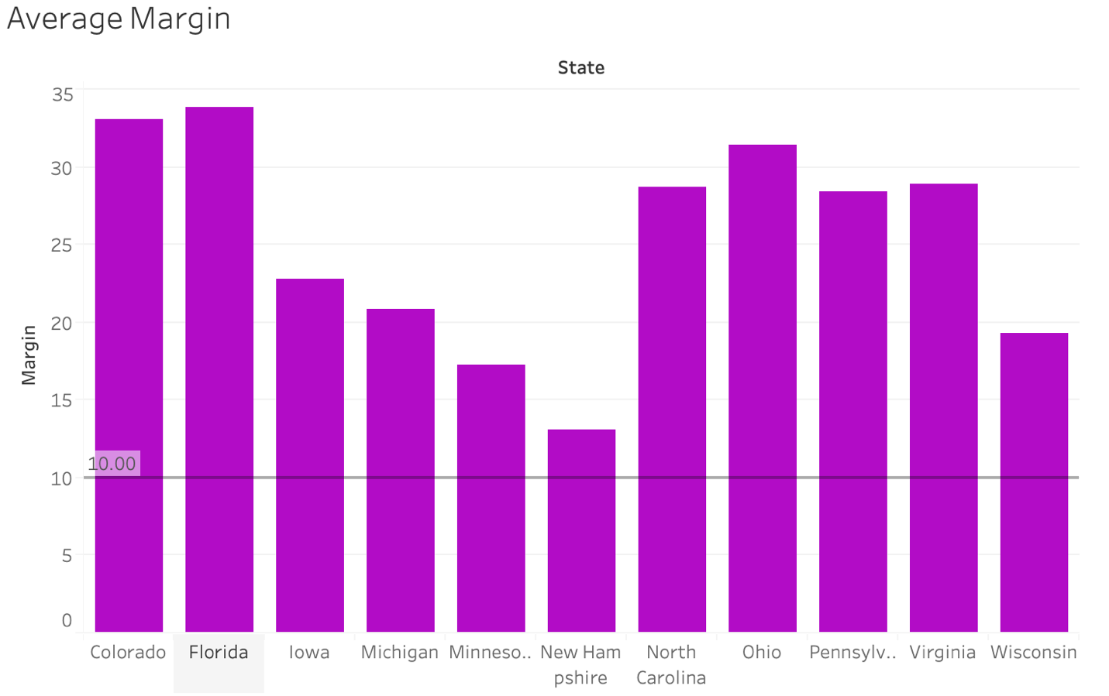

In general, parties won by over 10%. That is, most of elections within the counties, even within swing states were not close.

How often were the races close in each state?

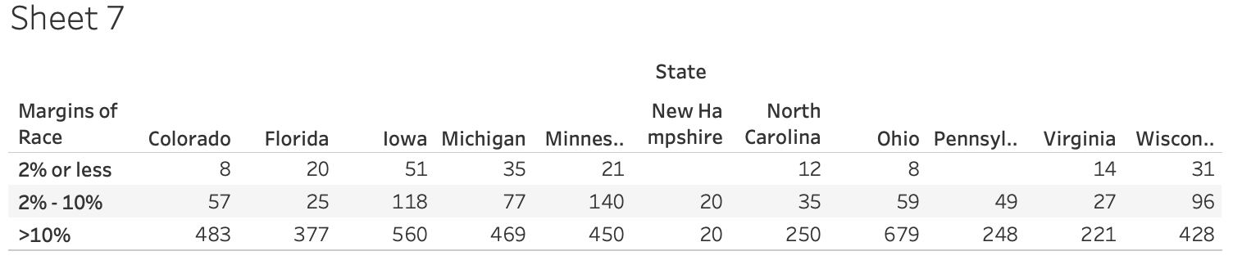

In general, the races were not close. However, in several states (Iowa, Minnesota, Wisconsin), about a quarter of the races were close or very close. In the case of New Hampshire, half of the races were close. While the number of close races in each race was not high, it was not insignificant.

*Was there a party split within close margins? As in, when the margin was small, did one party tend to win?*

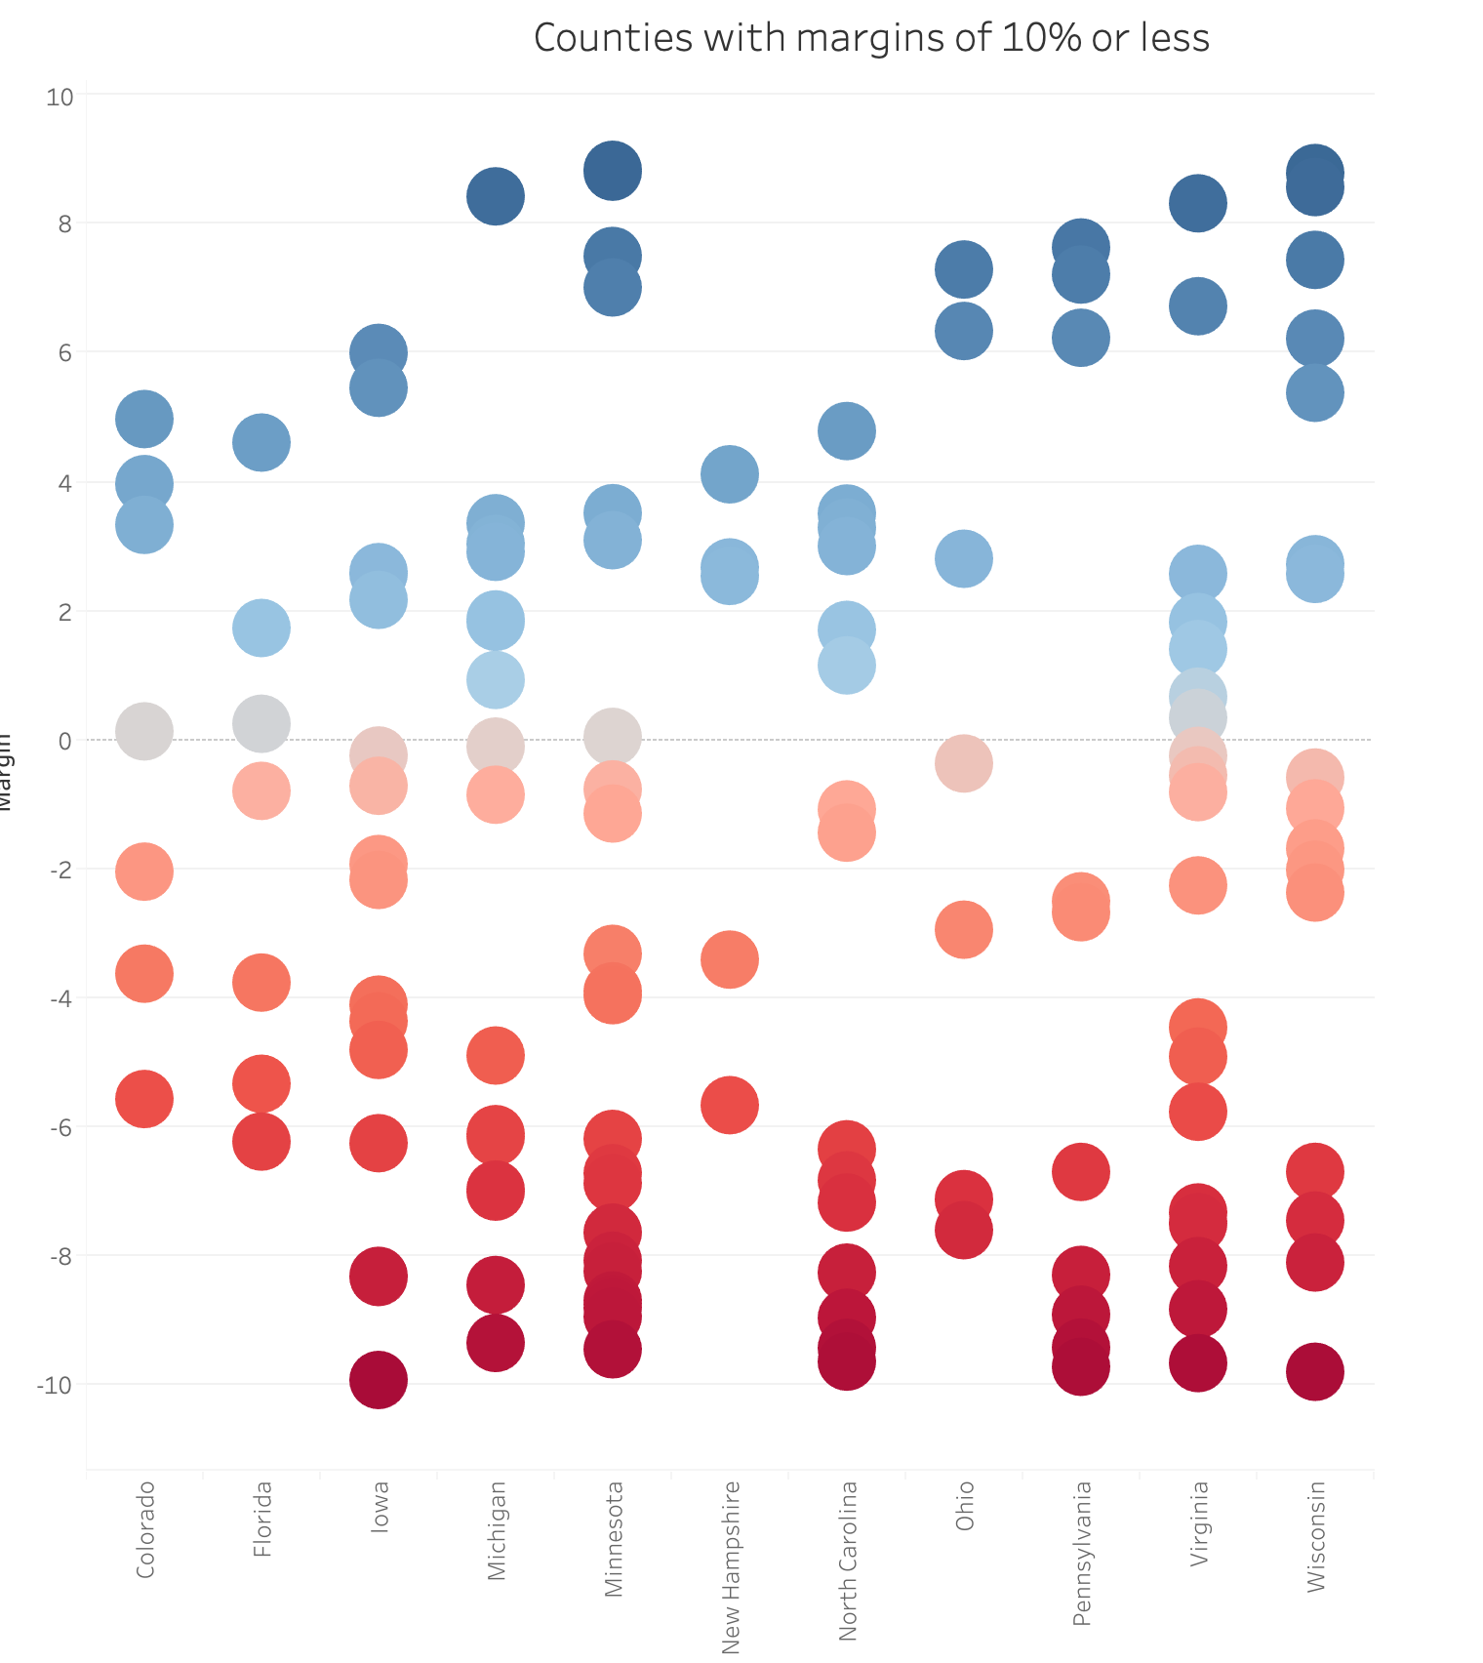

Looking at this graph, it seems like Republicans maybe won most of the close elections, but not conclusively. So we can’t really say whether mostly Democrats or Republicans tended to win close races.

**Conclusions**

Generally Republican states with high populations within counties near cities that make up for the popular vote.

Close races were not common in swing states, but they definitely happened.

**Generalizations, things to keep in mind, things I should do better**

* Only covers:
  + A few states
  + In the 2018 midterm elections
* Caveats: races, margins calculated
* Excluded “other” parties from consideration, for the sake of simplicity